“Unraveled”
The Rev. Katie Day
June 7, 2020
Genesis 18:1-15; 21:1-7

For the month of June, we are looking at the theme “Unraveled” in worship. This series comes from the folks over at Sanctified Art, and while I know you are no stranger to their work, I am delighted by their thoughtful words and beautiful art, and grateful for such a resource. We’ll spend four weeks looking at stories in scripture where something, or someone comes unraveled. Sounds about right for these days.

Now, I’m not a knitter – I’ve always wanted to be a knitter, but I haven’t wanted to learn to knit. That takes time and patience, and more time and practice. I want to already know how to knit. But, alas, it doesn’t work that way.

I have friends who knit, and my friend and former colleague Elaine was learning how to knit when we worked together, and I remember one time when she had finished the practice piece she was working on, and wanted to try again, she unraveled the whole thing, just pulled it all apart.

All that work. All that time. All that determination. GONE. Unraveled.

Here’s what the artists behind our worship theme have to say about it:
“What happens when our world falls apart? How do we press onward when our tightly-knit plans unravel into loose threads? What do we become when our identity—or the path we’re on—comes undone? What if all of this is not the end we fear it will be? In our unraveling, sometimes life surprises us with unexpected joy, love, and hope—with a new beginning we couldn’t have imagined. Sometimes we need God to unravel us, for we long to be changed.”
Today’s story starts off our series with the unraveling of expectations, as Sarah overheard God tell Abraham that they would give birth to a child. Very unexpected, given that she was 90 and her husband was 100, because, science. Joyful news, yes, but unexpected, life-changing, paradigm-shifting.

Of course, she laughed in God’s face at hearing this news, or rather, behind God’s back, listening at the door. Of course, Abraham laughed first, when he heard this same news in the previous chapter. If you’re unfamiliar with the story of this matriarch and patriarch of our faith, here’s a little history, a little context.

God called Abraham. That is essentially the beginning of this story. Well, God called Abram – his name was different before God changed it. That tends to happen – God calls, you respond, you are changed. God called Abram and his wife Sarai, later renamed Abraham and Sarah, told them to leave the land of their families and travel to a new land that God would give them, where they would become parents, grandparents, great-grandparents, great-great-grandparents to an entire nation of people, their descendants would outnumber the stars. God made a covenant with them, an agreement to be in relationship – this family would be God’s people, and God would be their God. And so they left, and they traveled. But here’s the thing – they were already, how shall I put it, “annually blessed,” or “advanced in wisdom” at the time of their calling and they had not been able to have children when they were younger. Still, they left, and they traveled, and they trusted, and they waited.

After awhile, the trusting and the waiting got old, as old as they felt. Get on with the covenant fulfillment, God – you promised!

Abraham took matters into his own hands, did some lying and some cheating – turns out he was quite a selfish manipulator at times. And Sarah took matters into her own hands. When Sarah took matters into her own hands, she instructed Abraham, her husband, to impregnate Hagar, her enslaved woman.
The way things worked back then, that surrogate child would be the firstborn, would count as the heir, the fulfillment of the promise. God helps those who help themselves, right?

Wrong! That is not in the Bible anywhere. In fact, I’d say most of our biblical narrative, and the heart of the Gospel, means to unravel that little worldly saying.

Sarah regretted this move almost immediately. She began to treat Hagar poorly, and Hagar ran away to the wilderness. An angel of the Lord came to her there, and told her to return home, and promised that God would also make a great nation of her son, who would be named Ishmael, meaning “My God hears and obeys.”

I’m going to fast-forward a little in our story here, to 12 years later, when Sarah did in fact give birth to a son, Isaac. For Sarah, something about seeing Ishmael, playing and laughing with Isaac, child of laughter, as too much. Her joy in motherhood unraveled, her delight was dampened by his very existence. And Sarah told Abraham to send away Hagar and Ishmael.

This is a complicated piece of our family tree of faith. Isaac is the child of promise, but Ishmael was his firstborn son, equally born to the man of promise. Isaac is the child of celebration, of fulfillment, of “finally!” but Ishmael is the child of anguish, of tension, of “what are we going to do now?” Thankfully, God stepped in.

And while Ishmael was not part of God’s original promise, that plan did not unravel, God simply made the plan larger. And just as God promised to Hagar when she was pregnant, God promised to Abraham now: Ishmael will be a great nation.

And Ishmael did become a great nation. The people of Islam trace their genealogy through him back to Abraham.

God’s promise to one man, Abraham, which became two promises, for two sons, became two nations, two faiths – Islam and Judaism, three faiths, once Christians joined the story, one ancestor for this family of faith, and just like all families, sometimes we are at odds with one another, and just like our great- great-, etc. grandparents Abraham and Sarah, sometimes we act beautifully, and sometimes we act shamefully. But we are all woven together, whether we like it or not, by God’s covenant.

The covenant that, in the beginning, was laughed at by both Abraham and Sarah. The covenant which both of them at various times tried to circumvent and hurry along, which seems to suggest they didn’t think very highly of God’s ability to keep a promise. But thankfully, God’s practice of keeping promises is not affected by either human faithfulness or faithlessness. God’s covenant holds, even as human plans unravel.

I know a little about that. In February of 2017, I was rehearsing the musical Godspell at a local theatre company when I got an email from the adoption agency that had done our home study, an in-depth examination and report on Kevin and myself, our health, our history, our marriage, our jobs, our housing.

The email was to the point: the agency had declared bankruptcy and was closed, effective immediately. Almost 2,000 adoptions in various states were disrupted in that moment. We had been officially waiting – all our paperwork was up to date, we were in the process but had not yet been matched with a family looking to place their child.

We had been waiting in some capacity or another for 7 years, after beginning our initial application in January of 2010. Things kept happening, and we kept waiting, even as more doors closed and we had to change our plans and expectations again and again. We had started completely over from scratch shortly before the news of this bankruptcy.

Let me stop for a moment to say that adoption is incredibly complicated, there is much that is broken in our system in the country, it is often unjust and predatory, transactional, and the children and birth families are the ones who suffer the most trauma. I would be glad to talk with you more about this if you want to hear more, or to listen if you have a story to tell.

That February, I joined 2,000 other potential adoptive parents calling every other agency in the country to see if they would take us in. No one knew what to do. This had never happened before. People stopped returning my calls, I left message after message to no avail.

I finished the run of Godspell; my song was “Learn Your Lessons Well”, and had I ever. When the show closed, I went to England and Scotland for a few weeks with family. I wandered through cathedrals and museums, and stayed a week on Iona learning about Celtic spirituality and resonating with the rocky coastline, the beaches of smooth pebbles, the freezing blue water.

When I came home from my trip, I turned our adoption over to Kevin. “I’m done,” I remember thinking. Let Kevin leave voicemails for awhile. I had a new show to rehearse, Peter Pan, summer youth ministry trips and events to lead, and Kev and I were about to leave for Montreat to co-preach 2 weeks of Youth Conference.

Of course, the first agency he cold-called answered the phone cheerfully and told him, of course they would help us out. Oh and by the way, they just got off the phone with a social worker who was working with a pregnant woman who was due to give birth very soon, were we interested in a referral?

We were leaving for North Carolina. I had signed a contract with the theatre. Also? It was a boy. And from day 1, I knew that we would adopt a girl. My entire life, I only ever envisioned myself raising a girl. Unraveled.

Kev looked at me across the room while on the phone, eyes questioning. Yes, obviously, yes. We scrambled to get our paperwork in order, including completing another home study, getting physicals, asking friends and family to overnight letters of recommendation.

We sent Elijah’s mother our book about the two of us, with essays about our hopes and dreams of becoming parents, photos of our home, our dogs, our church. We had a video call to meet face to face. We loved her from the moment we met her, and we have never been the same since. Unraveled.

5 weeks later, including 2 and a half at Montreat, frantically putting together a nursery with my aunt and long-distance help from our parents, generously equipped with all manner of baby gear by a shower from the theatre, we found ourselves once again waiting, praying, hoping that we were up for this incredible task we had longed for for so long. And then, it was time. Unraveled.

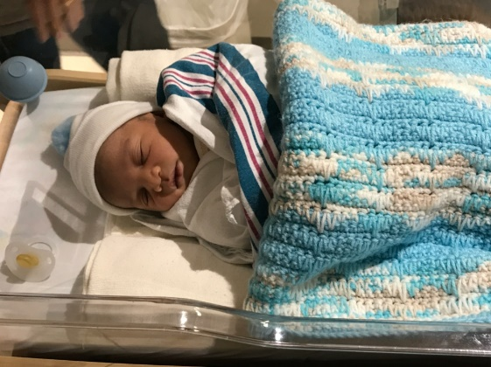

When we got to meet him, 3 days after he was born, we were afraid to touch him, to wake him, afraid we wouldn’t know what to do. As I shared in my video message to you all on Tuesday, we had just begun learning about what it might mean for us to raise a black boy in America. Also, we had just begin learning about parenting in general and how to care for an infant. Lots of training classes in our adoption process, none of them covered how much to feed your 3-day old baby, what does it mean when he breathes like this or his diaper looks like that or he sleeps or doesn’t sleep or cries or doesn’t cry?

I love this photo of Kevin with Elijah.

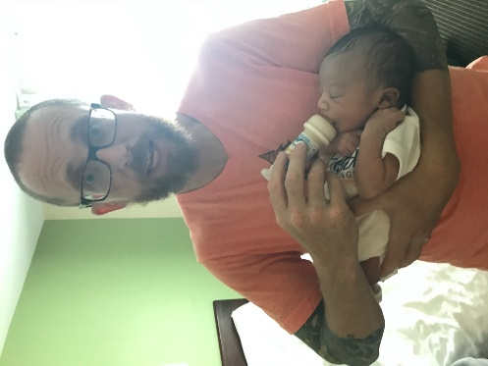
We had just walked in the door of our teeny hotel room from the hospital, and this brand-new baby started crying, and we fumbled around in the bag from the hospital with all the samples of formula, and finally I handed the teeny bottle to Kevin who fed a ravenous Elijah, and in that moment we just knew nothing would ever be the same again. Utterly unraveled.

3 years in, we are getting slightly more sleep, and Elijah is still ravenously hungry, and we still cherish our relationship with his birth mother and also his birth father, his siblings and grandparents, aunts and cousins, who are all our extended family now.

This life and our family isn’t perfect, and things aren’t always easy, and I imagine things will only get more complicated.

But the covenant holds. I learned something about knitting – you can knit an entire garment with one long piece of yarn. This is why you can easily unravel something and start again. But weaving needs at least two distinct strands, multiple threads instead of one.

God unravels our expectations, and weaves us into something new, something different than before, and something bigger and broader than we first imagined, weaving us into relationship with people
who will forever change the look of our lives.

Sarah and Abraham, our ancestors in faith, are connected through Isaac and Ishmael, to more than half of the world’s population. Can you imagine? No wonder they laughed. But the covenant holds.

We will celebrate communion in a few moments. This is God’s covenant in action, here we see in our worship most clearly how God takes our loose threads and weaves us together along with the great cloud of witnesses who have gone before us. Everyone’s in, and everyone’s welcome.

Whatever state of unravel you find yourself in, you’re invited to join in this sacrament and be connected to the wildest, most unruly, most unexpected ever-growing family – the kin-dom of God.

The covenant holds. Thanks be to God.

