“Big Hairy Audacious Goals”
Rev. Susan L. Haynes
Luke 9:28-36
February 23, 2020
Transfiguration Sunday

Luke 9:28-36
²⁸Now about eight days after these sayings Jesus took with him Peter and John and James, and went up on the mountain to pray. ²⁹And while he was praying, the appearance of his face changed, and his clothes became dazzling white. ³⁰Suddenly they saw two men, Moses and Elijah, talking to him. ³¹They appeared in glory and were speaking of his departure, which he was about to accomplish at Jerusalem. ³²Now Peter and his companions were weighed down with sleep; but since they had stayed awake, they saw his glory and the two men who stood with him.³³Just as they were leaving him, Peter said to Jesus, ‘Master, it is good for us to be here; let us make three dwellings, one for you, one for Moses, and one for Elijah’—not knowing what he said. ³⁴While he was saying this, a cloud came and overshadowed them; and they were terrified as they entered the cloud. ³⁵Then from the cloud came a voice that said, ‘This is my Son, my Chosen; listen to him!’ ³⁶When the voice had spoken, Jesus was found alone. And they kept silent and in those days told no one any of the things they had seen.

Big Hairy Audacious Goals, otherwise known as BHAGs. I don’t want you to forget the term so here’s a visual to help ensure you don’t.

A BHAG is a clear and compelling target for which an organization strives. The term was coined in Jim Collins and Jerry Porras’ book Built to Last: Successful Habits of Visionary Companies.
Put simply, a BHAG is a long-term goal that everyone in an organization can understand and rally around. BHAGs should cause excitement and energize people in a way that quarterly targets and lengthy mission statements often fail to do.

The litmus test of a BHAG is how it answers such questions as:
- Does it stimulate forward progress?
- Does it create momentum?
- Does it get people going?
- Does it get people’s juices flowing?
- Do people in the organization find it stimulating, exciting, adventurous?
- Are people willing to throw their creative talents and human energies into it?
Most organizations – if they wish to survive the long haul – have goals. There is, however, a difference between merely having a goal and becoming committed to a huge, daunting challenge…like putting a man on the moon.

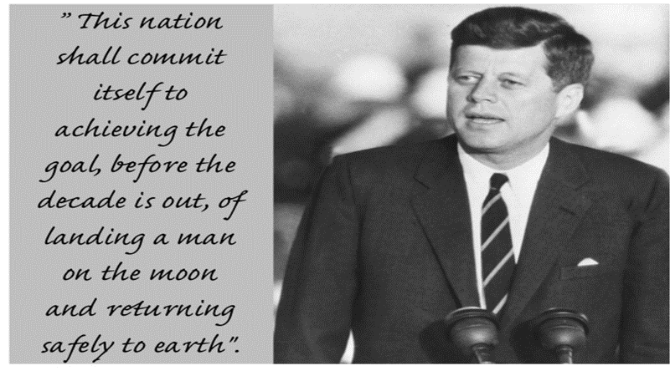
On May 25, 1961, President John F. Kennedy presented the people of the United States with a Big Hairy Audacious Goal.
“This nation shall commit itself to achieving the goal, before the decade is out, of landing a man on the moon and returning safely to earth.”

The most optimistic scientific assessment of the moon mission’s chances for success in 1961 was fifty-fifty. Nonetheless, Congress agreed – to the tune of an immediate $549 million –and billions more in the following five years to Kennedy’s BHAG. Today that $549 million would be equivalent to almost $4.75 trillion.

It was a bold and outrageous commitment. Not only did man indeed land and set foot on the moon on July 20, 1969, Kennedy’s BHAG was also responsible for beginning the United States and the entire world on a technological revolution that continues today.

The disciples of Jesus had left behind their former occupations to follow an itinerant rabbi around Galilee because they were compelled by his BHAG. But Jesus’ Big Hairy Audacious Goal was different from what the disciples thought it was. Their understanding was that Jesus’ BHAG was gritty and political…
the dream that someday their Roman occupiers would be overthrown…
God’s anointed king and messiah would sit on the throne…
God’s presence would return to the temple.
It was a vision of freedom from oppression with peace and security for all. It seemed like an impossibility given the number of Roman spears and warhorses that patrolled the roads and streets. But there was this Jesus who seemed to fit the mold of the kind of leader who could make it happen. He had performed amazing miracles, drawn huge crowds, and become somewhat popular with the people. Maybe he was the one who would reverse their fortunes and transform them from paupers into princes.

But Jesus’ BHAG and how it would happen was vastly different from theirs.
Earlier, Jesus had asked his disciples who they thought he was, and Peter answered, “The Messiah of God.” Jesus, however, would define the Messiah’s mission in far more graphic terms than Peter and the others could have imagined. Before being fitted for a crown, Jesus would embrace a cross.

It was an unimaginable scenario that day. Jesus pulls Peter, James and John aside and takes them up on a mountain. While Jesus was praying, his face and clothes were transformed into a kind of heavenly brilliance. It’s an image that reminds us of Moses’ meeting God on Mount Sinai when Moses’ face became so brilliant, he had to cover it with a veil afterward. That same Moses, and the prophet Elijah, show up to talk with the glorified Jesus.
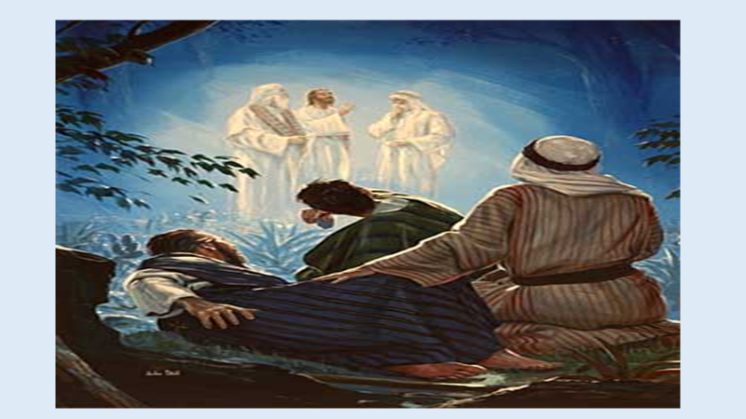
The key here is not so much the appearance of the two towering figures of the Old Testament, but the focus of their conversation. Luke says they were speaking of Jesus’ “departure” which would soon to take place in Jerusalem. The Greek word for “departure” is “exodus,” which puts Jesus’ mission into the larger context of the biblical story.

Remember, in the days of Moses, the Israelites were set free from slavery in Egypt — a BHAG for which they had prayed some 400 years. Their freedom was signified and subsequently remembered by the Passover meal and the blood of the sacrificed lamb that saved them from death and pointed the way to new life and a promised land. Jesus was about to initiate a new exodus that would deliver all of humanity from the enslaving power of sin. This deliverance would require a new Passover and a new once-for-all sacrifice as Jesus became the sacrificial lamb. This was Jesus’ BHAG: the salvation of the entire world!

The sleepy disciples saw this dazzling vision, but they still didn’t understand that Jesus was more than they imagined and his mission – his BHAG – was much more comprehensive than a political coup.
Peter piped up with an idea: “Master, it is good for us to be here; let us make three dwellings, one for you, one for Moses, and one for Elijah.”

On the surface, it sounds like a wonderful idea. But Peter’s construction plan essentially put Jesus on the same level as Moses and Elijah, which tells us that he still didn’t get who Jesus was. It took the cloud of God’s own presence and glory and his voice to set Peter straight: “This is my Son, my Chosen; listen to him!”
This is the Son of God, not just another prophet.
He is preeminent — not over and against the Law and the Prophets but as the one who interprets and fulfills them.
He is the ultimate fulfillment of the covenant promises God made to Adam, to Abraham, to Moses, and to David.
He is the one through whom all the nations of the earth will be blessed.
Jesus was God’s BHAG!

Jesus invites us to dream our Big Hairy Audacious Goals for the places we live and serve. Often, we have dreams, but they are ideas and goals that are acceptable to us…too small, too easily attainable. Jesus, however, invites us to be a part of the Big Hairy Audacious Goal of transforming the world, transforming the community around us, and yes, transforming ourselves.

Business leaders Scott Anthony and Mark Johnson argue that any good BHAG has at least three characteristics:
- It inspires. It’s the kind of goal that makes people sit up and pay attention and helps them imagine a different sort of future.
- It’s credible. It’s a goal that, while a stretch, has potential for success… remember the 50/50 chance of landing a man on the moon?
- It’s imaginative. It’s the kind of goal that offers a meaningful break from the past in order to embrace the future.
For Christians and for the church, I would add one more characteristic:
→ It must embrace and follow the leading of God’s Spirit.

You have heard the wonderful news that the Pastor Nominating Committee will be reporting to the congregation next Sunday regarding the results of their 2-year search for Pleasant Hill Presbyterian’s next installed senior pastor and head of staff.

What Big Hairy Audacious Goals will this church embrace as you live into this new season of your life with God, with each other, with a new pastor? What transformative worship and mission will the Spirit of God lead you to do? Whatever those BHAGS are, they will require commitment and sacrifice. They will require letting go of the way you think things should be done and the way things have always been done. They will require creativity and tenacity and excitement and courage. They will require that you listen to God…and listen to each other…and listen to those who have yet to come through the doors of this church… listen to those who will never come through the doors of this church.

What Big Hairy Audacious Goals will this church embrace as you live into this new season of your life with God, with each other, with a new pastor?

