October 21, 2018 – “Whose Are We?”
(Job 38 and Mark 10:35-44)
Rev. Jennie Sankey

If I gave each of you a piece of paper and a big box of crayons, and asked you to draw a picture of yourself in the universe, what would it look like? Some of the kids may already be working on this, but if you’re worship bag adjacent, maybe you want to grab a piece of paper too and start drawing. I’d love to see what you come up with. My guess is that most of us wouldn’t draw ourselves as a tiny almost unseen fleck hanging off the edge of the paper. Instead, we’re likely to draw ourselves front and center, surrounded by stars and planets spinning in the deep blue behind us.
We can’t help ourselves. In day to day life, it sure can feel like we’re at the center of things, managing time, family, work, play, rest, school, faith. I feel pleased at the end of the day when all things have gone as planned. When I woke up, walked my dog, did some yoga, came into work, communicated well with volunteers, worked on what’s coming up in Advent, took a youth out for ice cream, ran a quick errand on my way home, made it home to cook dinner, spend time with my family, and reset for the next day. The things we do tell us who we are and where we are, and what’s important to us. Especially when things are going well. But what about when they’re not?
Job knows something about everything spinning out of control.
Job has been suffering. He has lost everything-his family, his possessions, his health, his well-being. And he and his friends have been trying to figure out why. Why would God allow for such suffering? His friends claim that either Job must have done something terribly wrong, or that in the suffering he is experiencing an opportunity for building character, preparing him for future suffering. Yikes. They believe God is just, and that God ordered the world based on fairness and justice, so that the only explanation must be based on what Job has done. Job disagrees. Job can’t think of one thing he’s done to deserve this suffering. He thought he knew who he was, a righteous, faithful family man, who had been rewarded for his goodness with prosperity. So if God is all about justice, why would this be happening to him? He demands an explanation, not from his friends, but from God. His suffering is of course the only thing he can think about. Every part of his body, mind and soul hurts. He has argued, made his case to God, asking “WHY?” Incredibly, God replies.
The Message translation by Eugene Peterson begins God’s answer like this:
“Why do you confuse the issue? Why do you talk without knowing what you’re talking about? Pull yourself together, Job! Up on your feet! Stand tall! I have some questions for you, and I want some straight answers. Where were you when I created the earth? Tell me, since you know so much!” (Job 38:1-4, The MSG)

Job is blown away by God’s whirlwind of a speech. God’s answer (can we call it an answer?) reorients Job’s whole world. Job is reoriented in the vast universe of God’s creation as that tiny speck on the very edge of the piece of paper. You’ll notice that humans weren’t mentioned at all in this passage-and it goes on for another whole chapter. Snowflakes and dew drops and ravens…God’s creation is full of tiny and intricate detail. And while it sure is amazing, I suspect many of you may feel that this is not the straight answer Job is looking for. You may feel that God is avoiding Job’s question of “why,” by annoyingly saying “that’s for me to know and you to find out!” Or, you may not care so much about what God said in God’s response, but note that God showed up, assuring us that we are not abandoned and alone in our suffering. Or you may wonder if it’s crazy for us to think we can know anything at all about God from this story. After all, maybe we’re just a little fleck on the edge of the piece of paper. What if that insignificance isn’t such a bad thing?

This image, known as the Hubble Ultra-Deep Field comes to us from the Hubble Telescope. It’s an image of just a very small region of space from our point of view, that with the naked eye, looked like a few far off stars. But each point of light that you see in this image is a galaxy, each full of billions of stars! I think if God were having this conversation with us, this image might make it into the speech. Something like, “Where were you, Jody, when I made a very hot dense super force and it started expanding into galaxies beyond your imagination? Who can see the edge of our expanding universe?” It makes one feel very, very small, maybe even insignificant.
Theologian Barbara Brown Taylor has this for us to consider:
For Job, “being relieved of his seat at the center of the universe has turned out to be one more way of being loved.” Let’s hear that one more time. For Job, “being relieved of his seat at the center of the universe has turned out to be one more way of being loved.”
In our Gospel passage today, we hear James and John imagining their own picture of the universe. “Teacher we want you to do for us whatever we ask of you…Grant us to sit, one at your right hand and one at your left, in your glory.” Their picture has them sitting powerfully at the center of it all. Jesus answers them with questions, reminiscent of God’s questions to Job. And, he won’t promise them the center of the universe. Instead, he gathers all 12 of his disciples around and tells them, “whoever wishes to become great among you must be your servant, and whoever wishes to be first among you must be slave of all. For the Son of Man came not to be served but to serve, and to give his life a ransom for many.”
Perhaps being relieved of their seat at the center of the universe has turned out to be one more way of being loved for James and John. Jesus does not show love by being the most powerful, domineering tyrant dishing out justice over his slaves. He does not show love by preening his followers to become lords over others. He does it by serving us. Us tiny little flecks on the edge of the page. And he asks us to do the same.
In a few minutes, our new members will answer the question “Who are you?” And they will be prompted to answer, “I’m a child of God and my name is ___________.” When we enter membership in the church, we don’t have people tell us what they do, who their kids are, where they’re from…we have them answer with whose they are.
As children of God, just like Job, just like James and John and the other 10, our whole identity is grounded in our Creator. God is God and we are not. We are not gods. We are God’s with an apostrophe s. Whose are we? We are God’s.
God’s encounter with Job and Jesus’ conversation with his disciples asks us to rethink where we picture ourselves in the universe and how we understand our purpose. We aren’t at the center, with all the planets spinning around us. Maybe we are the tiny dot on the edge. But what we hear today is that God meets us there. God meets us in our suffering, in our questions, in our demands, and in our hope. When we remember that it isn’t all about who we are and where we are, but whose we are, we can begin to reorient ourselves in God’s glorious creation, following Jesus by serving. By being the least. By claiming our smallness, our insignificance, and living like we know whose we are-God’s.
Part of how we live out being God’s is in the ways we use our resources. Today marks the beginning of a new season of service and generosity at Pleasant Hill. We’ll kick off our “stewardship season” today with a fun BBQ at McDaniel Park. We gather to celebrate our place in the universe and people who might be a tiny fleck in the vastness of creation, but who are still taken notice of by God, and are generously given lives of abundance.
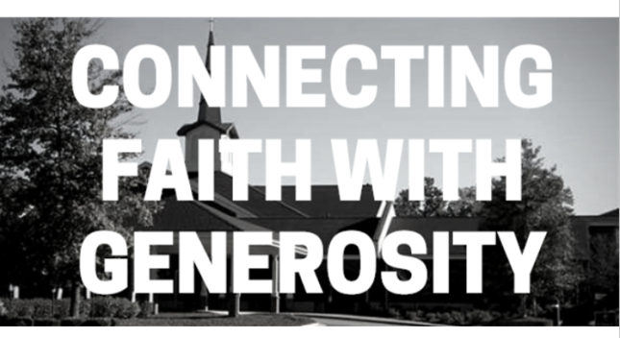
You probably received a little booklet in the mail this week titled, “connecting faith with generosity.” If you perused the pages, you saw the different ways your giving flows into the ministries of this church and out into the people of this congregation and the communities we partner with. To get to the summaries of that booklet, each committee of the church got together and produced a “ministry action plan” abbreviated as MAPs that laid out three steps: Identify, Clarify, and Mobilize. Your leaders reflected first on who they are, what they have been doing and are currently doing, and how they are planning to mobilize resources and people to continue doing ministry in this church.
At the beginning of each MAP, each committee was asked to describe their identity, who we are, and these are summaries of what each group came up with (on screen):
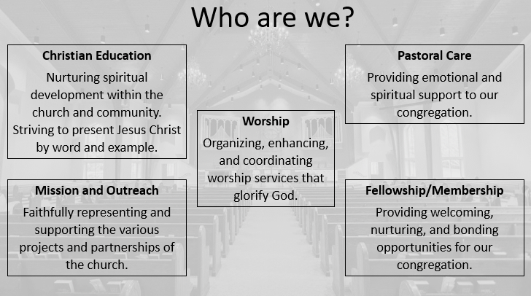
These “who are we” statement reflect some of the things we do and where we are in our ministries. They will help each group frame their goals and hopes for the coming year (3 years and 5 years and way down the road), as benchmarks of what they are striving for. And they will help each group determine how to utilize the money budgeted for their ministries.
It’s been a grounding process for us, as we look around and figure out how our congregation fits into the universe-the ways we impact the community, the ways we enter your everyday lives of faith, and the ways we aren’t. Sometimes in the process we have felt insignificant, inadequate, wishing we had more people, wondering if we made a difference, hoping that God has noticed. But smallness isn’t all bad, is it?
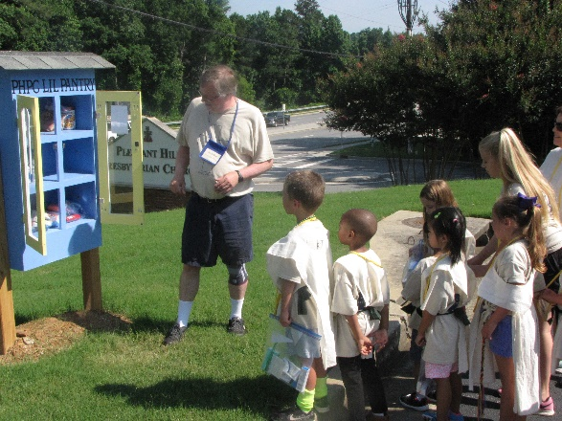

I mean look at our “Lil’ Free Pantry.” Angie Welch makes sure this is stocked and filled, because it is depleted weekly, with people coming by for food, or a pack of pencils, or diapers. Something so small, making a small impact in someone’s life, might be exactly what we’re supposed to be doing.
Remember the famous “Pale Blue Dot” photo, taken by the Voyager 1 spacecraft in 1990?
Taken from 3,720 million miles away, this is our first photo of our solar system from beyond the planet Neptune.
As astronomer Carl Sagan put it,
"That's here. That's home. That's us. On it everyone you love, everyone you know, everyone you ever heard of, every human being who ever was, lived out their lives. … There is perhaps no better demonstration of the folly of human conceits than this distant image of our tiny world."
When we recognize our smallness, and still try and serve with all we’ve got, we’re doing what God has created us for, we’re living as Jesus taught us.
So as you begin to ponder how this season of giving might fit into the universe, remember your picture of the universe again, with you as a teeny tiny fleck on the edge. How might your smallness, your insignificance, your servanthood, your being “God’s” with an apostrophe s fit into God’s grandness? Let that tiny dot be a reminder that we have been met at this tiny fleck by a God who speaks to us, questions us, and loves us enough to relieve us of being the center of the universe.

