“The Enemy Within”
Psalm 124; James 5: 13-16
Rev. Jody Andrade
September 30, 2018
Show of hands: who pays good money to go to scary movies? I do not understand you guys! Your thoughts are not my thoughts and your ways are not my ways. The rule in my home is very simple: don’t scare Mom. My family members love to scare one another but I am a giant chicken.
Scary movie lovers know a good scare can be fun if the threat is not real. Come with me back to the year 1994. There were eight of us, four couples, staying at the rental house. We needed two cabs to get us all home after dinner, and for some reason my husband Billy really wanted to jump in that first cab. I was finishing my coffee, so I stayed behind and caught the second cab with the Browns, the couple staying in the basement bedroom. When our cab arrived at the house, I walked into my bedroom and Billy was nowhere to be found. I shrugged my shoulders and started to get ready for bed. Suddenly, a terrified shriek, a high-pitched male? voice cried out from the basement. We all ran out of our rooms and rushed into the basement to find . . . Mr. Brown, splayed across a loveseat, gasping for air. And there was my Billy, collapsed on the bed, crying with laughter.
It seems that Billy had taken the first cab home so he could dash into the house and sneak down to the basement. When Mr. Brown arrived home with me in that second cab, he walked down to his room and began getting ready for bed. He shrugged off his blazer, slipped it onto the hanger and reached into the closet to hang up his coat. And as his hand extended, Billy from inside the closet went, “Ahhhhhh.”
You see, Mr. Brown and Billy had been messing with each other since they were teenagers. And even today, the battle rages on.
This is Maslow’s pyramid of human needs.
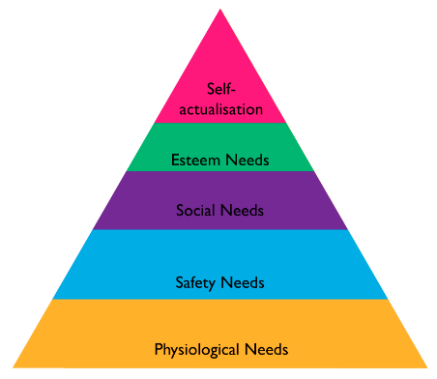
As the human needs on the bottom are met, you can move up the pyramid. You can see only the most basic needs of water and food and sleep, the physiological needs, are more essential than safety. Human beings need to feel secure.
In the movies, you get suspenseful music to let you know when something frightening is about to happen, when the “bad guys” are going to appear. Last time I preached we heard just a few notes from “Jaws” and everyone in this room got a little tense. In real life, the bad stuff, the enemy, doesn’t arrive with its own sound track. And in real life, the enemy, whomever it is that we need to be protected from, whatever it is we need to conquer, can attack us when we feel most safe: with our good friends, in our own homes, and yes, even inside our own heads.
Our nation heard a woman’s trembling testimony this week about feeling unsafe, being under attack, being, to use the language of today’s scripture, “ensnared.” We also heard a man emotionally defend his honor, deeply distraught by accusations of wrong-doing. Their testimony led to a flood of other people, both men and women, sharing their own struggles in public forums, including social media. Some stories were recent, but many were memories from the distant past that had been buried for years. Four of the stories were posted by minister friends of mine, and gosh, I had no idea. Three of the stories I read were posted by people linked to this very church. There are likely people here this morning with their own stories as well. Like the woman at the well, the hemorrhaging woman, and the boy possessed by a demon, people who are fearful, who are doing battle with principalities and powers are part of the Christian narrative. Jesus himself showed us how to respond: by seeing them, by listening to them, by offering them the Good News. We trust the Holy Spirit even now is with people who are bringing their struggles into the light.
Many enemies that threaten to ensnare us, to drown us, don’t wear a menacing mask and chase us down a dark ally. In fact, some of our most mighty enemies are not embodied. They exist in our brain. Addiction. Rage. Anxiety. Depression. They are “the enemy within.”
The last three Sunday evenings, Pleasant Hill hosted workshops entitled “Let’s Talk . . . Mental Health.” That clever title, as well as the workshops, were the brainchild of two of our teenage members, Anna Steingruber and Jillian Zinn. After yet another school shooting, these young women were tired of the blame landing on the broad term of “mental illness” with throwaway lines like “the shooter was crazy.” Anna and Jillian believed that talking about mental health, bringing words like anxiety and depression into the light, is the first step in fighting this invisible enemy.
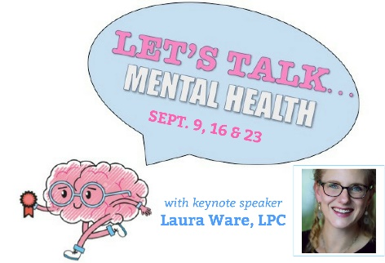
These days, the church is often accused of lacking authenticity. Joel talked about a lack of authenticity last week. In the church, while words like joy and praise have echoed through our halls for thousands of years, we often hide difficult, real-life emotions, like depression and anxiety. We put on a “brave face” on Sunday mornings.
Why the brave face, the lack of authenticity? It makes sense to me. If we are, as scripture tells us, “wonderfully made” by God, any battle with mental health might make us appear less than holy. Any dent in our armor might indicate a deficit of faith. We mistakenly think good Christians are perfects saints. The truth is, we are a lot closer to the embattled hemorrhaging woman or the Roman centurion.
If we can’t be real, to God and to our fellow Christians as we sit in these very pews, then yes, the church is failing us. The people who are the church have to do better.
The most sacred moments in ministry are when we have the courage to admit our vulnerabilities and our fears to one another. The most safe place, the most secure feeling comes with a church friend saying, “I hear your pain. Let’s pray together and find a way through this. Together we will find you the help you need.”
Some of the enemies we battle are invisible. So it may seem with God. But just because you don’t see God, don’t always feel God, doesn’t mean you are alone. Jesus is called Emmanuel, which means “God with us.”
God lived among us 2000 years ago, embodied. Fully God, fully human, Jesus showed us how to live. And he showed us what to do with our power as a church. In Matthew’s gospel, Jesus on the cross “cried out with a loud voice, ‘My God, my God, why have you forsaken me?’” He is alone, and feels abandoned by God just at the moment of his death. Theologian Dr. George Stroup says Christ’s willingness to go to the cross and submit to the power of death means there is no depression so deep, no illness so great that Jesus has not been a part of it. Is there any stronger act than for God with unlimited power to choose full submission to death? There is tremendous power in taking on weakness. As Christians, we too are called to use our power to take on weakness. Christ on the cross is where we look for the strength it takes to endure any tough battle.
Perhaps you’ve heard of one or more of these people? Actress and singer Kristen Bell. NBA player Kevin Love. Actor Dwayne “The Rock” Johnson. Model Gisele Bündchen. Each of them superstars, the very best in their chosen profession. Each one living what looks like a perfect life. And each one a person suffering in battle against an enemy within: depression, anxiety and thoughts of suicide. These seemingly perfect people are hurting and they’ve chosen to share that publicly, knowing they may feel better admitting their vulnerabilities.

Today’s James text tells us, “Are you among the suffering? Pray. The prayer of faith will save the sick and the Lord will raise them up.”
God answers prayer. Not in the way that we insist, but in God’s way. Isaiah 55: God’s thoughts are not our thoughts and our ways are not God’s ways. God answers prayer through trusted friends, through a counselor, through medication, through a safe environment. Emmanuel, God with us, provides us with strength, acceptance and healing.
The Lord is the light of the world and through Jesus Christ the darkness is banished. The darkness of self-medicating, of ignoring the problem and hoping it will go away. The darkness of faking it, of pretending all is well, of keeping the battle deeply buried and swearing to go it alone.
When you call the enemy by name and bring it into the light, it loses power. An authentic church listens for those words of truth and tells you that you are loved anyway. You yelled at your kids on the way to church this morning? You are forgiven. You gave your spouse the most cutting look you can muster? Mercy is yours. You’re hiding something from your loved ones or the world? No matter what it is, there is help, there is grace, there is understanding. This is an authentic community and this church is a place where you can share your truth. Every member here is in ministry, for we are a priesthood of all believers. The staff here is always ready to provide pastoral care.
Therefore confess your sins to one another, (be real with one another!), and pray for one another, so that you may be healed. Why? Because the Lord is on our side. Let Israel now say, “the Lord is on our side!” Can I get an authentic “Amen?”
Amen.

