Things that Matter: Peace in Your Heart
Mark 4: 35-41
Rev. Jody Andrade
June 24, 2018

Have you ever risen before dawn down on the south GA coast, gone down to the dock and paid the tournament entry fee, and boarded a boat? You motor to the pogie boat where you buy your bait, and then head out to sea? It’s a 2-hour ride ONE WAY to the fishing spot and you just know the stirrings in your stomach are butterflies of excitement for this new adventure. You’re deep sea fishing for the first time! You’re in a boat with your trusted friend, an expert fisherman!
Wow, these butterflies sure are fluttering! I wonder if drinking more coffee would calm them down? Maybe a jelly donut would feel good too? Hey Captain, how long have we been riding on these swales? Oh, just 7 minutes?
And then you lose sight of the shore. And you’re bracing your legs to take the thump, thump, thump of the seas. And your expert fisherman friend observes, “Wow, the chop is really rough this morning!” and you notice if you look closely you can see the bottom and the top of every wave.
And maybe those butterflies have multiplied or perhaps turned into aliens kung fu fighting in your stomach. Your friend notes your green face and says, “Jody, whatever you do, don’t go down to the bottom of the boat. It’s the hardest place to be because you lose visual perspective!” But you think well maybe if I just go visit the restroom I’ll feel a bit better and so you do and you get thrown against both sides of that restroom as the boat rocks. Then you scramble back up the ladder so you can start letting all of those butterflies and aliens and last night’s butterbeans and the coffee and donut you had this morning over the boat railing and into the water. (Now you’re only 20 minutes into a 2-hour ride one way to get to the fishing spot.)
Don’t go into the bottom of the boat. Don’t lose visual perspective. In my friend’s boat—way down in the bottom—though I may have uttered Jesus’ name multiple times in fervent prayer, I promise you Jesus Christ was NOT down there. Jesus was NOT in that boat.
In today’s scripture we read that in the middle of the story, in that rolling boat with waves crashing over the sides, Jesus WAS deep in the boat. He was breathing evenly and deeply, eyes closed, perhaps even with a slight smile on his lips. He may have been thinking the words Saint Julien of Norwich famously wrote a thousand years later, “All shall be well and all shall be well and all manner of thing shall be well.”
The Harper Collins Study Bible says sleeping in the Bible, in stories like Job or the poetry of the Psalms, is “a typical posture of trust in God.” Jesus knew it was all good. Jesus, fully human and fully God, knew all would be well.
Joel preached about parables these last few weeks, about how a story can illustrate a larger concept and we draw wisdom through our own interpretation of the story. The Gospel of Mark was written for followers of Jesus who were afraid during a terrible life storm. It was about the year 70, the time of the Jewish war, civil turmoil in Rome and just after the death of Emperor Nero, the cruel Roman ruler who crucified Christians upside down. These readers of Mark, these 3rd generation disciples of Jesus, were afraid and could not see Jesus! They were people in need of a parable or a story that spoke to them.
Let’s return to the story of wind and waves and Jesus asleep. The Sea of Galilee sounds like an ominous obstacle to cross for many reasons. The Disciples are alone, on one tiny boat WITHOUT an outboard motor. The boat is crossing at night, and let’s face it, everything is more frightening at night. The boat is getting swamped with water. Visualize The Perfect Storm, as Mark Wahlberg and George Clooney eye the giant wall of water that will topple their boat. The spiritual leader Jesus, “O Captain, my captain!” is asleep in the stern. The waters are dark and deep and in the first century even the fishermen among them are sure that lurking just below the surface are innumerable “demonic monsters.” And the monsters you can’t see are often the most frightening. 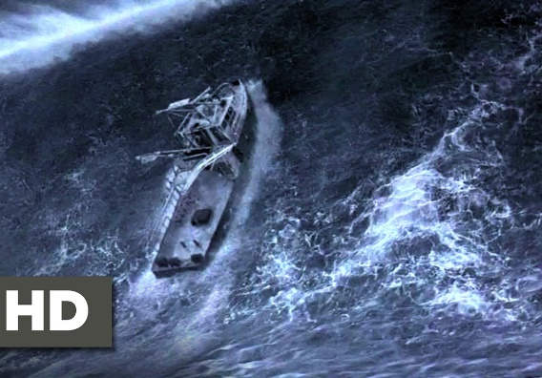
Female Soloist: O sing a song of Galilee, of lake and woods and hill, of him who walked upon the sea and bade its waves be still. For though, like wave on Galilee, dark seas of trouble roll, when faith has heard the Master’s word, falls peace upon the soul.
The four gospels of Matthew, Mark, Luke and John all describe Jesus’ ministry in the familiar Western area of the Sea of Galilee. The population on the Western shore was Jewish. Judaism is more than worshiping a particular way on the sabbath. It describes an entire culture, a way of life. It is how Jesus and all of his disciples lived.
This story in Mark is Jesus’ first reported crossing from the well-known Western side of the water, from home, to the Eastern shore, where the Gentiles lived. In other words, Jesus and the disciples were traveling away from their world, to a new context where they would be very much out of place. It’s scary to travel to a new place, and doubly frightening if you know the new place will find your beliefs strange and perhaps even hostile. The disciples were sailing across known waters but into unchartered religious and cultural territory.
Raise your hand if you’ve been to the Sea of Galilee. I haven’t been there but I read about it, and my preacher friend Rev. Jennie Sankey told me about it. Here she is wading in the water. 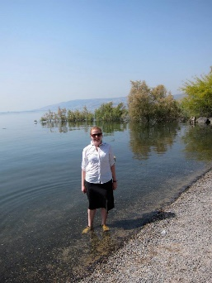 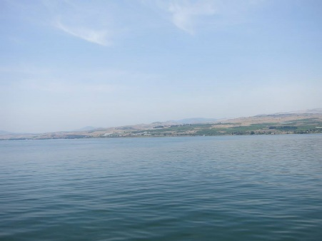 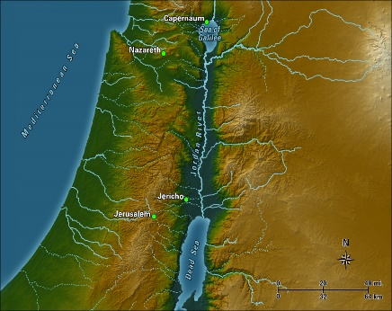It looks more like a lake than a sea. Compare it to something familiar—like Lake Lanier. The Sea of Galilee and Lanier are both freshwater. The Sea of Galilee has 32 miles of shore line, compared with Lake Lanier’s 692 miles of shoreline. The Sea of Galilee is 141 feet deep, and Lanier is over a thousand. Jennie tells me you can see all the way across this “sea” to the other side.
Is it possible the journey across the Sea of Galilee wasn’t as physically imposing as the disciples imagined? That they were not about to perish in the storm? Verse 36 confirms there were other boats traveling with them, a sign of Jesus’ growing ministry. The disciples’ boat holds 15 people, many of them fishermen who are comfortable on the water. And most importantly, unlike the fishing story I told earlier, Jesus is in the boat. He’s in the stern sleeping peacefully, all shall be well. So when Jesus calms the storm and asks the disciples, “Why are you afraid? Have you still no faith?” we recognize deep, valuable parabolic wisdom because Jesus is asking us those questions.
What frightens you? What about the journey to the unfamiliar Eastern side of the Sea of Galilee fills your heart with fear? Is it uncertainty about your own life? Your vocation, your marriage, your health? Is your heart troubled by the choices your loved ones are making?
Or are your fears wider? Are you squinting into the darkness, anxious to see what this church will be in 5 or 10 years? Are you fearful of unknown creatures swimming just below the surface of our American waters, monsters like future school shootings, racist and sexist acts, muffled cries of separation or abandonment, or perhaps the scariest unseen monster: the eerie silence of many Americans during this storm? Do rocket tests in Russia and nuclear weapons in North Korea and rising temperatures and heightened oceans and international posturing keep you awake at night? How can Jesus be quietly sleeping in the stern when we are being tossed to and fro and taking on water?
Rev. Matthew Ruffner recently wrote to his Dallas congregation, “I invite you today to seek to trust that all belong to God and to live like we belong to one another. For this is the invitation of Christ.”
There is comfort in knowing everyone in this sanctuary is in the boat. All of us, children of God and yet only human, feel a little seasick and concern about taking on water? Is there comfort in knowing all of us, at times, lose sight of Jesus? Even though he is living among us, in the Word and in one another?
Male Soloist: O sing a song of Galilee, of lake and woods and hill, of him who walked upon the sea and bade its waves be still. For though, like wave on Galilee, dark seas of trouble roll, when faith has heard the Master’s word, falls peace upon the soul.
When Jesus rebuked the wind with “Peace! Be still!” the disciples were relieved. Actually, they were more than relieved; the disciples were in awe. The Greek literally translated says the disciples “feared a great fear.” Not the weak, frightened fear of the Cowardly Lion, but an awesome fear, a “numinous [otherworldly] sense of awe that accompanies a theophany [a human encounter with God].” Like the awe that saturated Moses at the burning bush. Like the awe of the “terrified” shepherds when the angel of the Lord appeared. That awe empowered Moses to lead people out of slavery. That awe shepherded the infant Jesus safely away from Herod’s murderous gaze.
We encounter the power of God every day, through congregation, through community, through the Word. We will cross to the other side, to the Eastern shore, safely. There is help. There is hope. Jesus is rebuking the wind and quieting our hearts with the words, “Peace! Be still!” God is still speaking through the Word and through this community to each of our anxious hearts. May we all move past frightened fear and experience the otherworldly sense of awe that comes from encountering God.
O sing a song of Galilee, of lake and woods and hill, of him who walked upon the sea and bade its waves be still. For though, like wave on Galilee, dark seas of trouble roll, when faith has heard the Master’s word, falls peace upon the soul.
“All shall be well and all shall be well and all manner of thing shall be well.” Amen.

Harold W. Attridge, et al, ed, The Harper Collins Study Bible, New York: Harper Collins Publishers, 2006, p. 1732.
Daniel J Harrington, Ed. Sacra Pagina, Vol 2: The Gospel of Mark, John R. Donahue, S.J. Collegeville, Minnesota: Liturgical Press
Ibid, p. 161.
Exodus 3: 1-6
Luke 2: 9

