“The Rainbow Connection”
Genesis 9: 8-17
Rev. Jody Andrade
February 18, 2018

Can you tell what kind of rainbow this is? It’s the kind of rainbow that arched over Pleasant Hill Presbyterian the day Carol Ann Stough’s daughter was married. After a rainy start to the day, the bride and groom emerged to a burst of color. This rainbow is a sign of the covenant of marriage.
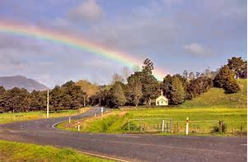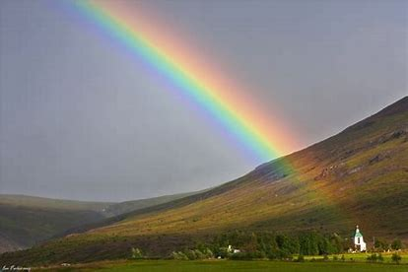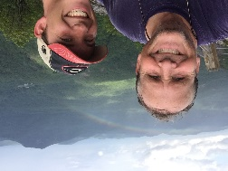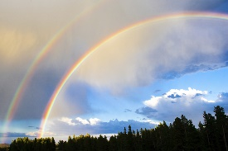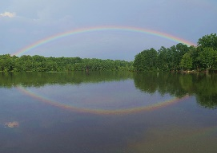
And this rainbow? This is the type of rainbow that decorated the sky at Glen Helmstetter’s nephew’s wedding. It was the first time the family had gathered since Glen’s funeral and Amanda says it was pretty clear that this was a wave from Glen. This rainbow is a sign of the covenant of presence.
How about this one? This was taken by David Hudson when he was hiking with his son. This rainbow is a sign of God’s covenant to journey with us.
How about this rainbow? After one member’s nephew’s funeral, a double rainbow appeared. Perhaps someone was so broken, so deeply hurt by the loss of this young man, God decided to double down on the message of assurance-- that especially in the depths of grief you are claimed and you are loved. This double rainbow is a sign of the covenant of belonging.
And finally, what kind of rainbow is this? It’s so perfect, so beautiful and Mike Buffington swears that he took this from his backyard. So it’s either a backyard blessing rainbow –or a photoshop rainbow. The jury is still out on that one. (Mike, it’s beautiful and we believe you!)
Last month the Fellowship/Membership committee of Session was gathered at a restaurant, looking at today’s scripture, for a “text talk” session. The name says it all--we read the text together and we talk about it. Text talk. After reading through these verses several times, one person volunteered this thought. Isn’t it strange, he said, that a rainbow comes out after the rain? After the flood, after the tragedy, after the “deed is done,” that’s when God gives us a rainbow. What good does that do? Things are already flooded. Who needs a rainbow when all is lost?
That wise observation came from a church member who has been very active in mission work through PHPC. He’s been to Honduras, Haiti, Guatemala, the Amazon and North Georgia. He’s built relationships and rebuilt homes, dug trenches and poured cement. Much of his work has come after a storm—a natural storm like a flood or earthquake, or a human storm created by civil unrest or intolerance. Both types of storms bring a community to its knees. Sure, a rainbow is pretty, but what good does it do after the rain?
Our corner of the world was driven to its knees again this week. On Ash Wednesday we gathered to be reminded of our own mortality. We emerged from our worship services to the news of 17 deaths in a Florida school shooting. To preach about rainbows so soon after that tragedy might seem dangerously trite. Rainbows? Life is not all sunshine and rainbows, is it?
In 1988, professional golfer Davis Love III was in Hawaii when he learned his father’s airplane flight in Georgia had disappeared from radar. By the time Davis flew from Hawaii to his layover on the west coast, authorities had discovered the plane wreckage and confirmed that all the men on board, friends and golfers from Sea Island, were dead. The families of each of those men were shattered, and the small community of St. Simons was plunged into shock. Davis lost his dad who was his teacher. Part of Davis’ sadness was that his dad, his teacher, his hero, had not lived to watch him win a major golf tournament.
And then, almost 9 years later, Davis fulfilled his golfing potential by winning a major, the 1997 PGA Championship at –wait for it—Winged Foot Golf Club. And as he hit his final putt into the hole and it was clear he would take home the trophy, what would appear? A rainbow. Like Amanda Helmstetter recognizing Glen’s wave to them at his nephew’s wedding, Davis knew that this was his dad celebrating, setting off seven colors of fireworks for all the world to see.
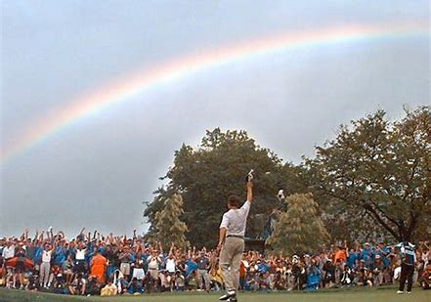
So back to the wise question from text talk. Why do we get a rainbow after the storm? Why does Davis get a rainbow after he’s endured the death of his teacher, his father, his hero? Perhaps because there was still rain in Davis’ life.
In the first chapter of the gospel of John we read that John the Baptist came to testify to the light; to tell us Christ, the light, was coming. God and the light are one and the same. And as John tells us, the darkness cannot overcome the light.
You see, the light needed to make a rainbow is always there. Always. Sometimes it’s blocked by the moon, we call that “night,” but the light is still there. And sometimes there are clouds in the way, but the light is still there. And we only see a rainbow when that ever-present light hits the rain. When we most need it, when we are emotionally or physically wrecked, when it is still raining in our lives—that’s when God pulls out all the stops. Behind that rainbow is a promise from that very source of light.
Glen Helmstetter’s family felt the ache of his absence at the wedding, but that bit of sunshine bouncing off the rain made it just a little more bearable. Davis winning the PGA did not erase the pain of losing his father, but the mixture of that sunshine moment with the rain he had endured sure did make for a gorgeous picture.
Let’s not overlook that the focus of this text is not the rainbow. When we read these verses we focus on the rainbow because we’re a visual species. We remember colors and signs much more easily than words. But let’s look at the words. God says the bow is God’s covenant with creation, with all living things SEVEN times in this one paragraph. SEVEN.
Why SEVEN times? At text talk, one person said it reminded her of when a parent scolds a child out of frustration rather than love. After the parent loses her temper and scares the dickens out of the kid she comes to her senses and says, “Oh--Sorry sorry sorry sorry sorry sorry sorry!” Our text talk friend wondered if God looked around at all the loss from the flood and was moved to make a covenant—a binding promise—and say it to us not once or twice, but SEVEN times in a row.
Or perhaps it was the other way around. Are there any marketing majors here? Do you remember the “rule of seven?” It means a consumer needs to hear or see your product seven times before they will buy it. I think that might be what’s behind this message from God. Maybe God knows we need to hear this promise seven times to begin believing it. Tragedies can shake your faith. Mudslides in California, earthquakes in Mexico, a suicide in your peer group, a shooter killing seventeen—seventeen at a high school or 50 in the Pulse Nightclub shooting in Orlando, or 59 in Las Vegas.
Tell me again, God, about your promise not to destroy everything.
Barbara/Mary Don read to us from Mark: Jesus was baptized and went into the wilderness and was tempted and came back to call disciples and begin his ministry. Jesus came to Galilee proclaiming the good news of God.
Tell me again, God, about the Good News. Speak to me the words from John 3, that Christ came to this world not to condemn it but to save it.
God started fresh with Noah’s family. If you read just a few more verses ahead you’ll discover it didn’t take long for Noah’s family to start messing up again. And we’re made of the same stock. We keep messing up too. With all of our weapons—our words, our posturing, our marginalizing and our AR-15s.
As the text talk session wrapped up I heard this last gem: “Rainbows to me mean hope. They give us hope for future generations.”
Me too. When I see a rainbow, I see hope. God names God’s covenant with us seven times, more than enough times for me to “buy in” to this absolute truth. We’re not seeing a rainbow right now but gosh, I’ll be looking for one. For that God-promised rainbow connection. Maybe I’ll see a rainbow up in the sky. Or maybe I’ll find brilliant colors in the words and deeds of my fellow human beings. In the selfless way teachers responded last week. In the advocacy that will grow out of this week’s tragedy. In the way a disaster brings a community together. It’s raining. But there is light. And God has promised, SEVEN times, to send us a rainbow.
How fitting that following the dusty message of mortality of Ash Wednesday, poet Langston Hughes would close us with these words: “Oh, God of Dust and Rainbows/help us to see/that without the dust/the rainbow would not be.” Amen.

